SIMATS ENGINEERING (SAVEETHA SCHOOL OF ENGINEERING)
Department of Computer Science and Engineering
ASSESSMENT TOOL 2– Case Study (2 QUESTIONS)

Course Code: | ITA05 | Course Title: | COMPUTER VISION
CO Assessed: | CO3 – Precision (BL4) | Assessment: | Assessment Tool 1 – Case Study
Weightage: | 40% of CIA | Total Marks: | 20 (2 Questions × 10Marks)
CO1 Statement: | Analyze and extract image features using detection and matching techniques for effective image representation and comparison..(BL4)
Student Name: | CHAVALI CHANDU | Reg. No.: | 192472332
Section / Batch: | SLOT D | Date: | 08/08/26
2
Code of Conduct
I CHAVALI CHANDU(192472332)(Name / Reg No) certify that this submission is my original work and that I have adhered to the guidelines specified for this assessment. I understand that any violation of academic integrity rules will result in disciplinary action.

Signature of the Student:
Instructions
- This test contains 2 questions, each carrying 10 marks. Total: 20 Marks.
- No negative marking. Unanswered questions carry zero marks.
- No calculators or electronic devices permitted.
- Duration: 60 minutes.

Section / Topic | Focus | Q Nos | Marks
Feature Detection and Matching | Preprocessing, Edge Detection, Harris Corner Detection, Hough Transform, SIFT | 1 | 10
Feature Detection and Matching | PCA, Image Representation, Feature Matching, Image Processing Applications | 2 | 10
GRAND TOTAL: |  | 20 Marks

Annexure A –Case Study

- A remote sensing application is used to align satellite images of the same geographical region captured at different times for monitoring environmental changes. The system initially relies on edge detection to identify matching regions between the images; however, due to differences in illumination, image orientation, and background details, the matching process becomes unreliable and produces inaccurate alignment results. The development team decides to replace the edge-based approach with Harris Corner Detection to identify stable and distinctive feature points. Analyze the limitations of edge detection in this application and explain how Harris Corner Detection improves feature localization, matching accuracy, and robustness for image registration under varying imaging conditions.

Case Study: Harris Corner Detection for Image Registration
1. Problem Statement
Consider a computer-vision system that must align two images of the same geographical area captured at different times.
For example:
- Image 1: Satellite image captured in January
- Image 2: Satellite image captured in July
- Goal: Align both images and identify environmental changes.
Initially, the system uses edge detection to find corresponding features. However, differences in illumination, orientation, shadows, and background details produce incorrect matches.
Therefore, the system replaces edge detection with Harris Corner Detection.
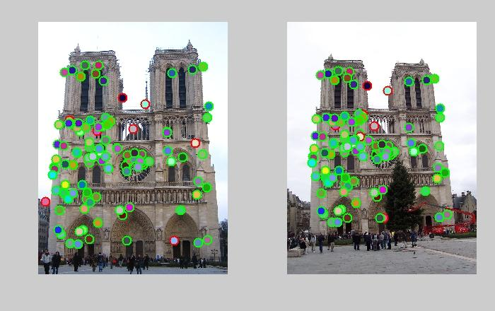
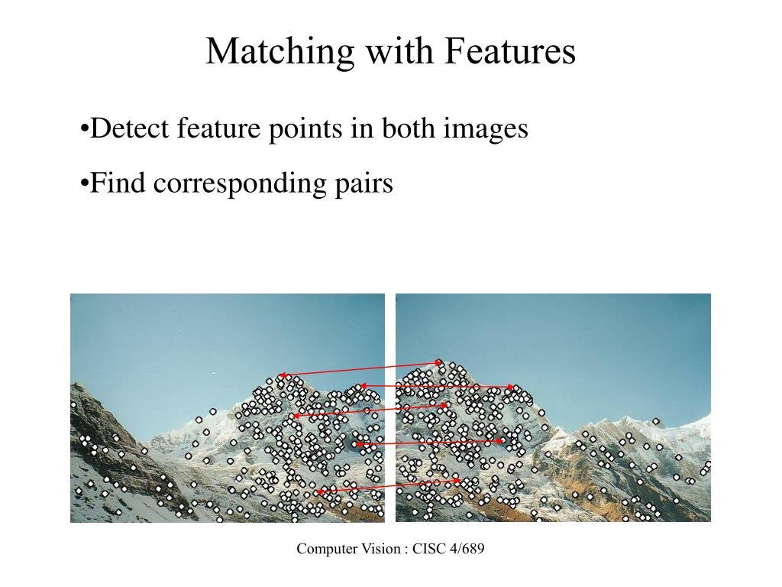
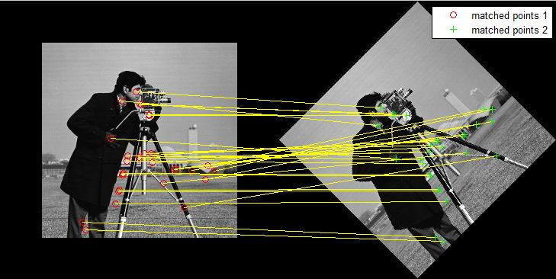

2. Edge Detection in Computer Vision
An edge is a location where there is a significant change in image intensity.
Common edge detectors include:
- Sobel
- Prewitt
- Roberts
- Canny
For example, Canny edge detection can produce an image like this:
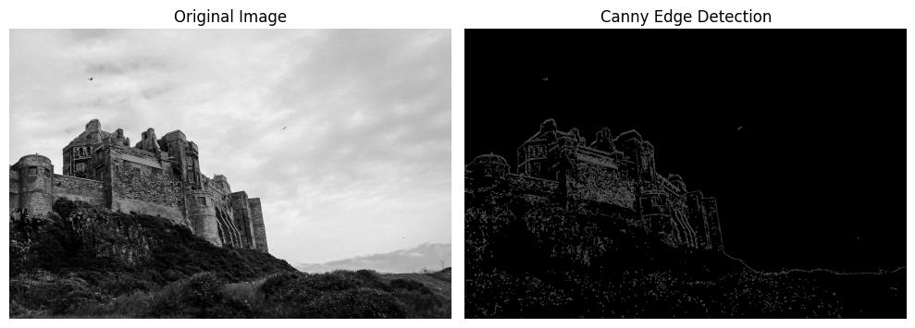
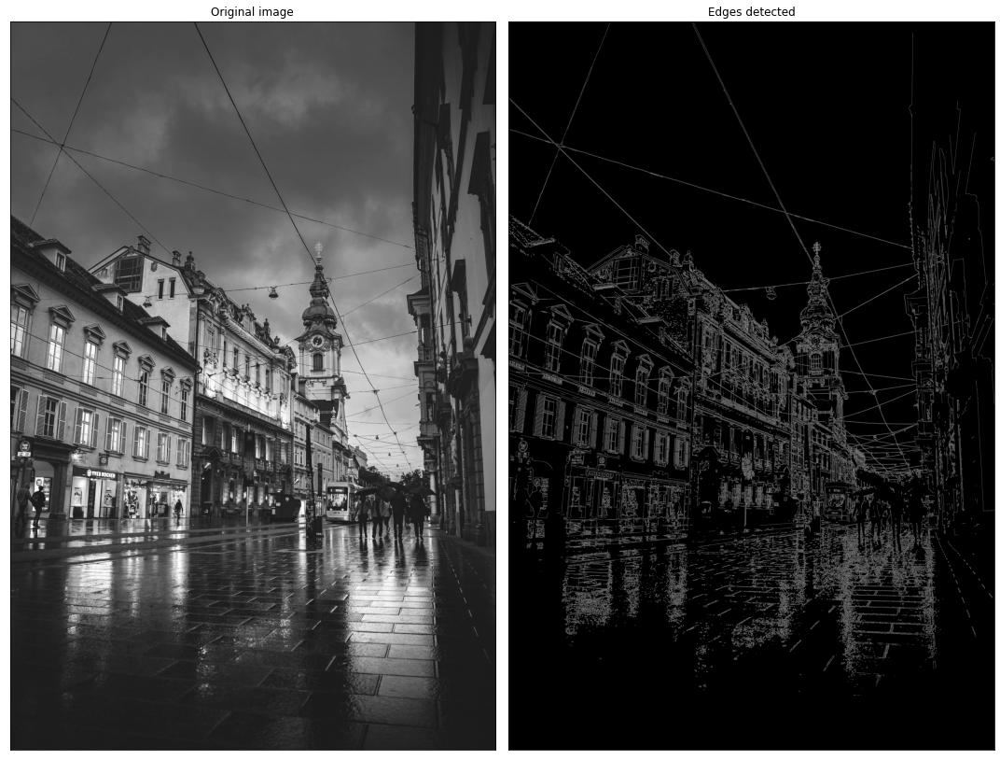
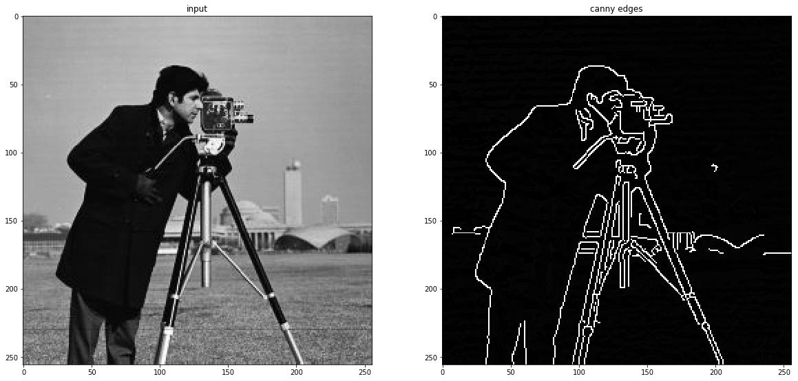
5
Why does this cause problems?
Suppose the image contains a building.
Original Building

┌──────────────────┐
│ │
│ │
│ │
└──────────────────┘
Edge detection mainly gives us:
┌──────────────────┐
│ │
│ │
│ │
└──────────────────┘
The algorithm knows that there are boundaries, but it does not necessarily know which particular point on those boundaries should correspond to the second image.
Therefore, matching becomes ambiguous.

3. Limitations of Edge Detection
A. Poor feature localization
An edge is a line, not a single distinctive point.
If an edge is 100 pixels long, many points along that edge may look similar.
Therefore:
Edge → Many possible correspondences
rather than:
Distinctive point → One likely correspondence

B. Sensitivity to illumination
Suppose the same object is photographed under different lighting conditions.
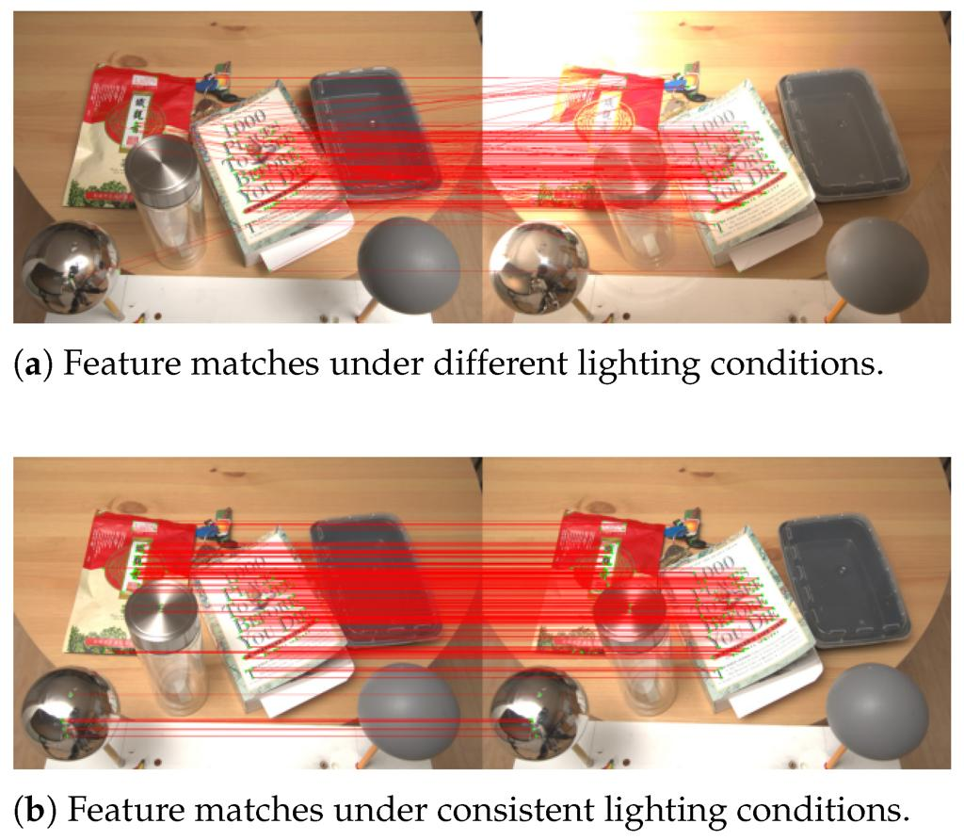
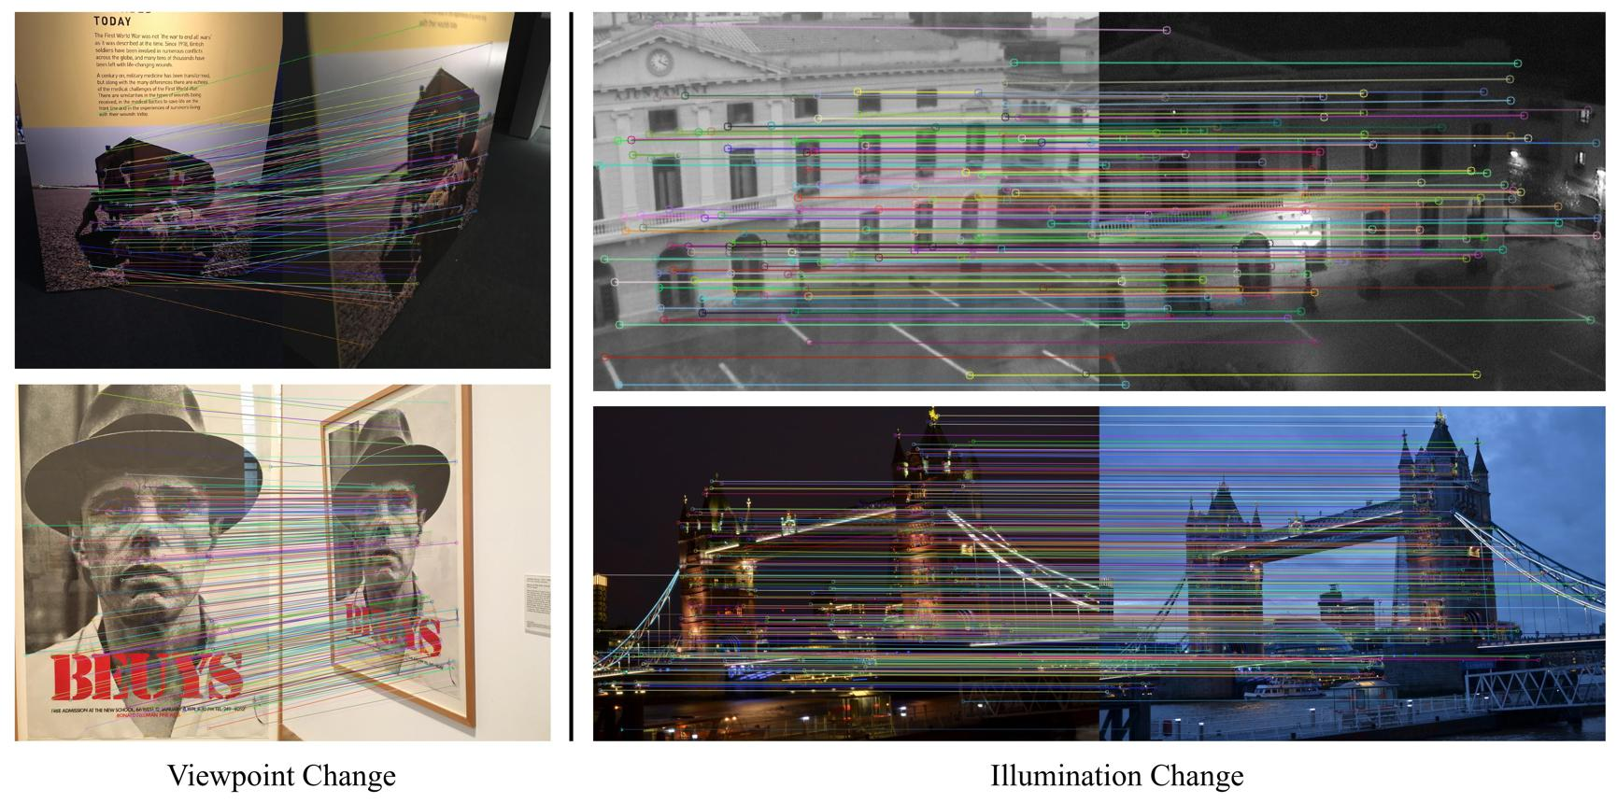
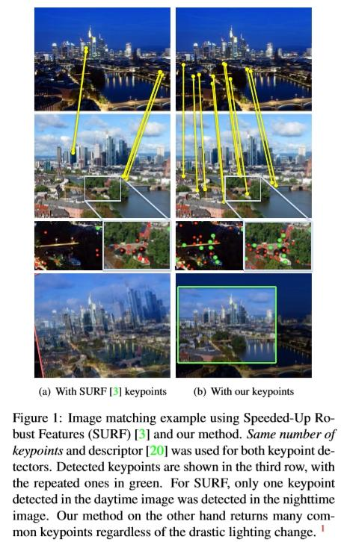
6
The intensity gradient may change, causing some edges to become stronger or weaker.
Therefore:

C. Background changes
Objects such as:
- trees
- clouds
- shadows
- vehicles
- water
- vegetation
can create additional edges.
These edges may not represent stable features.
Hence:

D. Orientation changes
If the second image is rotated or viewed from a different angle, the position of edges changes.
This makes direct edge-to-edge matching difficult.

4. Harris Corner Detection
Harris Corner Detection is a feature detector used in computer vision to find distinctive points called corners.
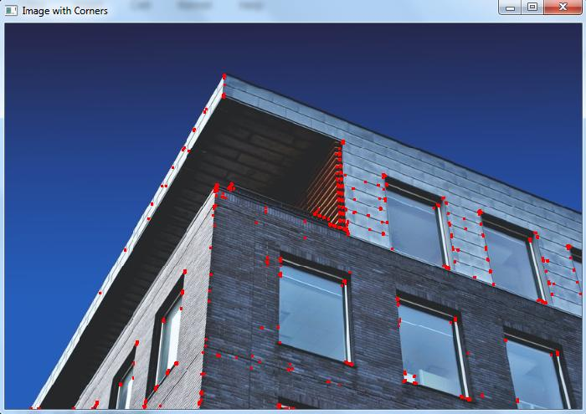
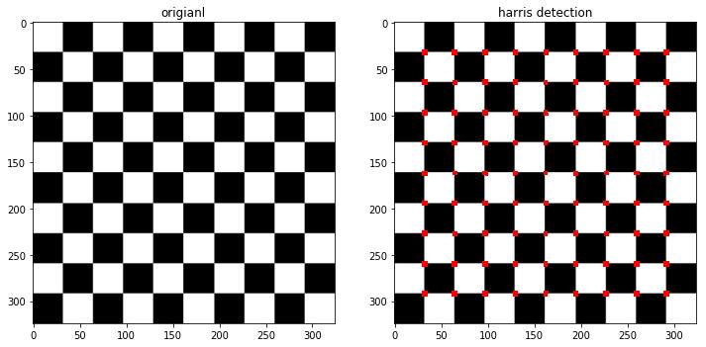
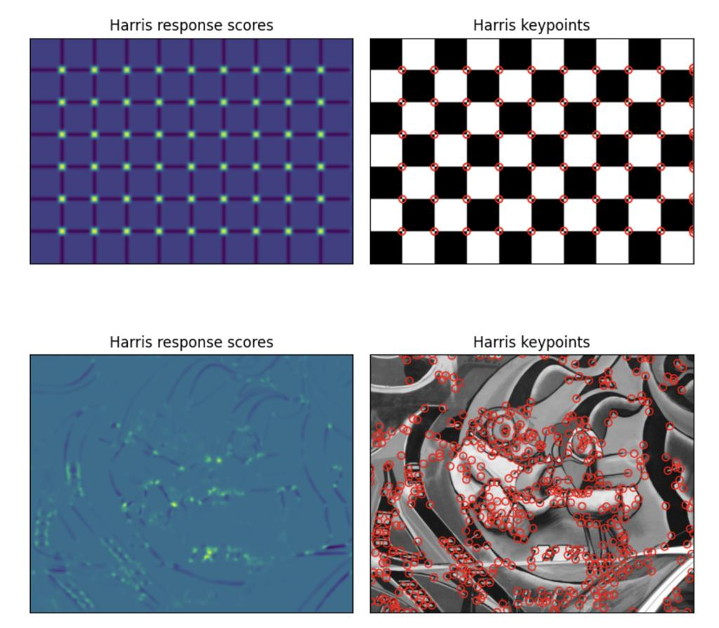
5
A corner is a location where image intensity changes significantly in two directions.
For example:
Vertical change
↓
██████████████
██████████████
────────●─────
──────────────
──────────────
↑
Horizontal change
The point ● is a corner.

5. Harris Corner Detection Principle
Harris examines a small window around every pixel.
If the window moves:
Across a flat region
Very little intensity change occurs.
Across an edge
Intensity changes mainly in one direction.
Across a corner
Intensity changes in two directions.
The Harris response is:
where:
and:
- = intensity gradient in x-direction
- = intensity gradient in y-direction
- = structure tensor
- = empirical constant

6. Why Harris is Better for Feature Matching
The key advantage is localization.
Edge-based method
Image
↓
Edge Detection
↓
Long boundaries
↓
Ambiguous matching
↓
Registration errors
Harris-based method
Image
↓
Harris Corner Detection
↓
Distinctive corner points
↓
Feature matching
↓
Geometric transformation
↓
Accurate registration
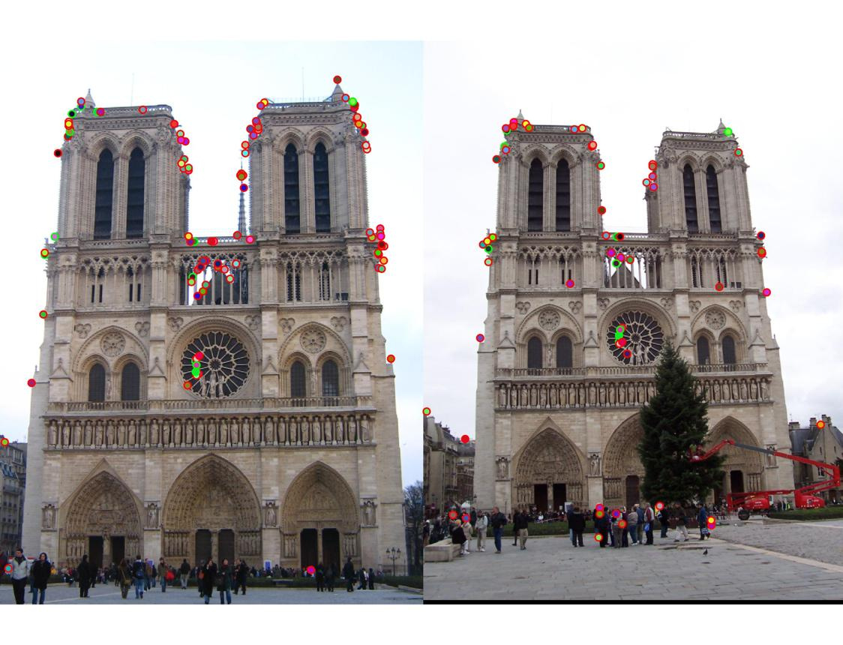
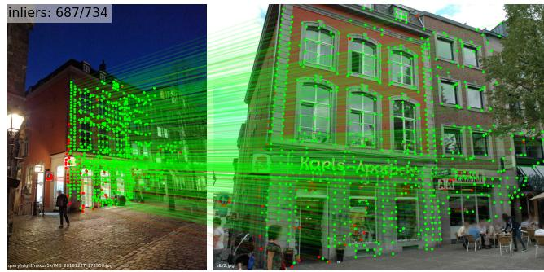

4

7. Computer Vision Case Study
Scenario
Suppose we have two images:
Image A
A building photographed from one viewpoint.
Image B
The same building photographed from a slightly different viewpoint.
The system needs to align Image B with Image A.
Using Edge Detection
The system detects:
- roof boundaries
- wall boundaries
- window edges
- shadows
There may be many similar edges.
The algorithm can accidentally match:
Window edge A
↓
Roof edge B
This produces an incorrect transformation.

Using Harris Corner Detection
Harris detects distinctive points such as:
Building corners
Window corners
Door corners
Object intersections
For example:
Image A Image B

●──────────● ●──────────●
│ │ │ │
│ │ → │ │
│ │ │ │
●──────────● ●──────────●
Corresponding corners can be matched:
A1 ↔ B1
A2 ↔ B2
A3 ↔ B3
A4 ↔ B4
These correspondences are then used to calculate the geometric transformation.

8. Image Registration Pipeline
This is the main diagram you can draw in your Computer Vision exam:
IMAGE 1 IMAGE 2
│ │
▼ ▼
Harris Detection Harris Detection
│ │
▼ ▼
Corner Points Corner Points
│ │
└────────────┬──────────────────┘
▼
Feature Matching
│
▼
Corresponding Points
│
▼
Transformation Estimation
│
▼
Image Warping
│
▼
REGISTERED IMAGE

9. Comparison
Parameter | Edge Detection | Harris Corner Detection
Feature | Edge/line | Corner/point
Localization | Less precise | More precise
Distinctiveness | Low to moderate | High
Matching ambiguity | High | Lower
Feature correspondence | Difficult | Easier
Background sensitivity | High | Generally lower for stable corners
Image registration | Less suitable alone | More suitable
Computational concept | Gradient/edge | Second-moment matrix
Output | Edge map | Corner/keypoint locations

10. Advantages of Harris in This Case
1. Better feature localization
Harris identifies a specific pixel location rather than an entire edge.
2. Better matching
Corners are more distinctive than long, repetitive edges.
3. More reliable registration
Multiple corresponding corners can be used to estimate the transformation between images.
4. Reduced ambiguity
A road intersection or building corner is generally easier to match than an arbitrary point along a road edge.
5. Useful for geometric transformation
The detected points can be used to calculate:
- Translation
- Rotation
- Scaling
- Affine transformation
- Homography, depending on the scene and imaging geometry

11. Important Limitation of Harris
For a Computer Vision answer, mention this point because it shows deeper understanding:
Harris Corner Detection is not completely invariant to large changes in scale, rotation, or illumination.
So, if the images have major viewpoint or scale differences, a modern system may use Harris with additional descriptors/matching methods, or use detectors such as SIFT, SURF, or ORB.
Thus, the practical pipeline can be:
Harris Corner Detection
↓
Feature Description
↓
Feature Matching
↓
Outlier Removal
↓
Transformation Estimation
↓
Image Registration

12. Final Case Study Conclusion
Case Study:
A computer-vision-based remote sensing system is used to register satellite images captured at different times. The original edge-based approach produces inaccurate correspondences because edges are extended, ambiguous, and sensitive to illumination, orientation, shadows, and background changes. Harris Corner Detection improves the process by identifying localized points where image intensity changes significantly in two directions. These corner points are more distinctive and can be matched between images to estimate the required geometric transformation. Consequently, the images can be aligned more accurately, improving subsequent environmental change detection. However, basic Harris detection is not fully invariant to large scale, rotation, or illumination changes, so additional feature descriptors and robust matching techniques may be required in practical systems.

- An autonomous surveillance system continuously captures high-resolution color images to detect vehicles and pedestrians in real time. Processing the original color images directly increases computational complexity and slows down feature extraction, making it difficult to achieve the required processing speed. To improve system performance, the engineers consider converting the images into grayscale or binary representations before applying feature detection algorithms. Analyze the impact of different image representations on computational efficiency, edge detection, and feature extraction performance, and justify the most appropriate image representation for achieving accurate and reliable object detection in real-time computer vision applications.

Case Study 2: Image Representation for Real-Time Object Detection
1. Problem Statement
Consider an autonomous surveillance system that continuously captures high-resolution images using a color camera.
The system must detect:
- 🚗 Vehicles
- 🚶 Pedestrians
- Other moving objects
The original images are in RGB color format.
The problem is:
High-resolution RGB images contain a large amount of data, increasing memory usage and computational cost.
Therefore, the engineers consider converting the images into:
- Grayscale
- Binary
before performing edge detection and feature extraction.
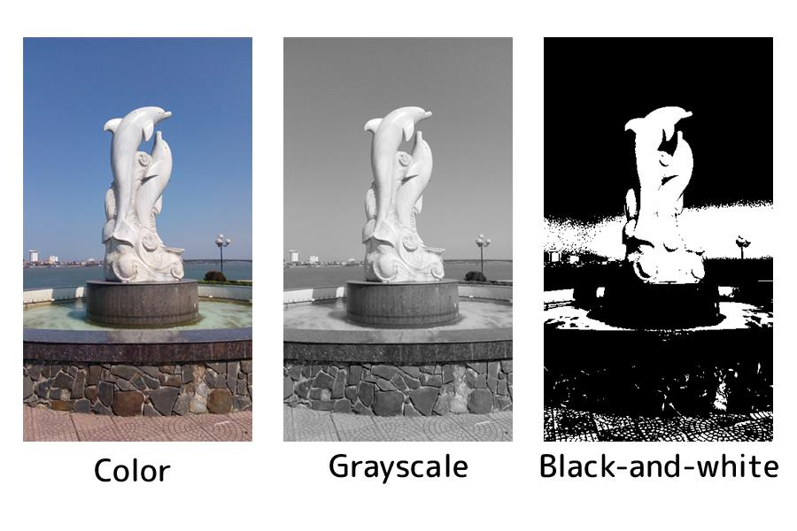
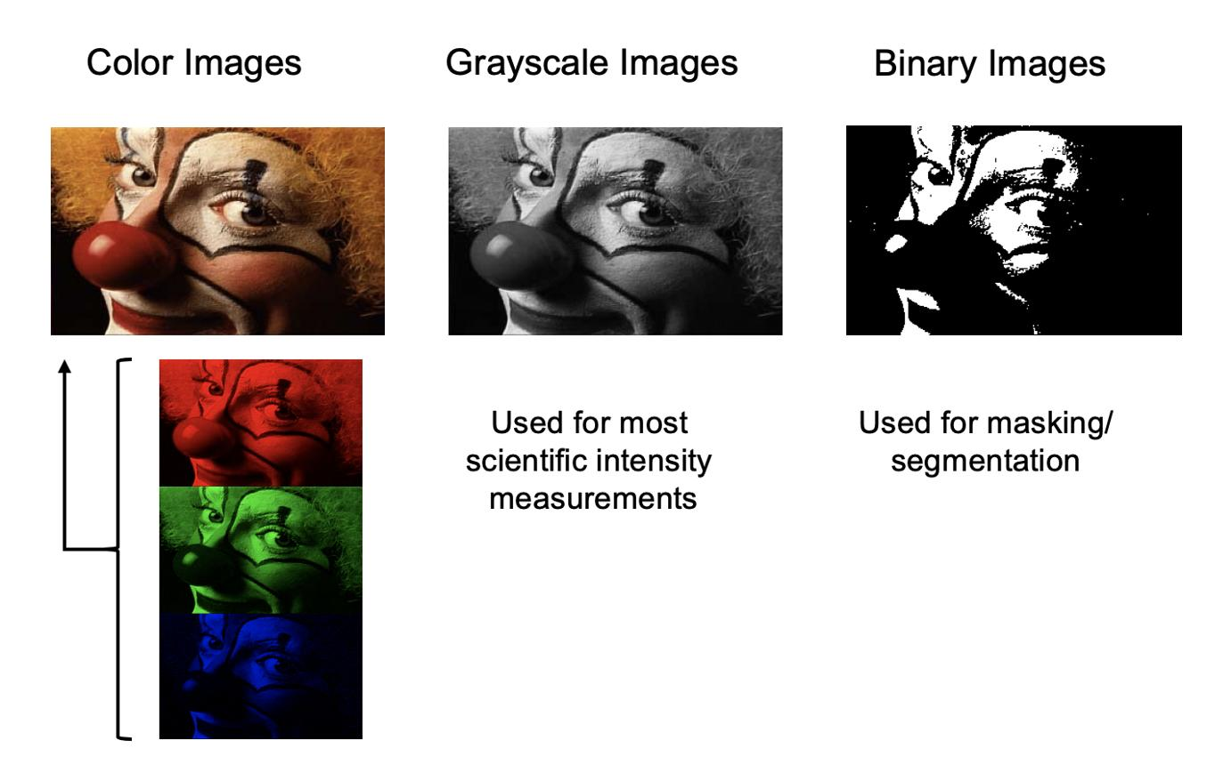
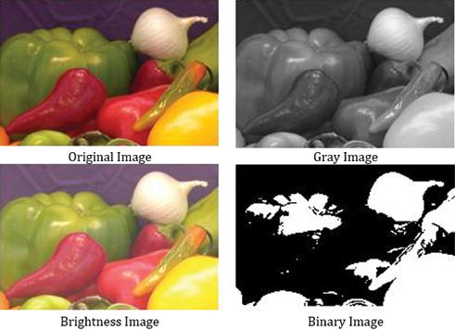
2. Different Image Representations
A. Color/RGB Image
An RGB image contains three channels:
Each pixel contains information about:
- Red
- Green
- Blue
For an 8-bit image:
So, a high-resolution RGB image contains a large amount of data.
Example
RGB IMAGE

┌─────────────────────────┐
│ 🚗 🚶 │
│ │
│ 🚗 │
│ 🚶 │
└─────────────────────────┘

3 channels:
R + G + B
Advantages
- Preserves complete color information.
- Useful when object color is important.
- Can distinguish objects with similar shapes but different colors.
Disadvantages
- High computational cost.
- More memory required.
- Edge detection must process multiple channels.
- Feature extraction becomes slower.

3. Grayscale Image
A grayscale image represents intensity using a single channel.
A commonly used conversion is:
Instead of:
we have:
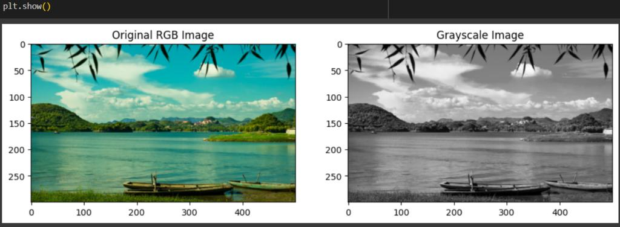
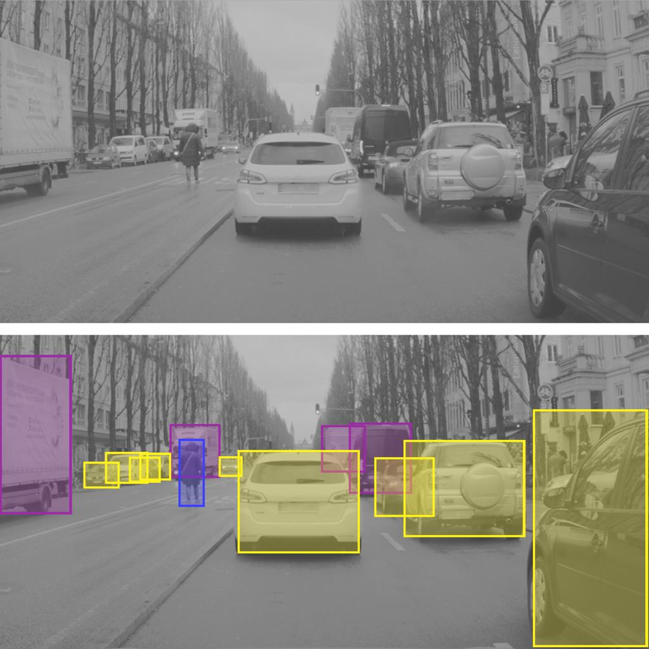
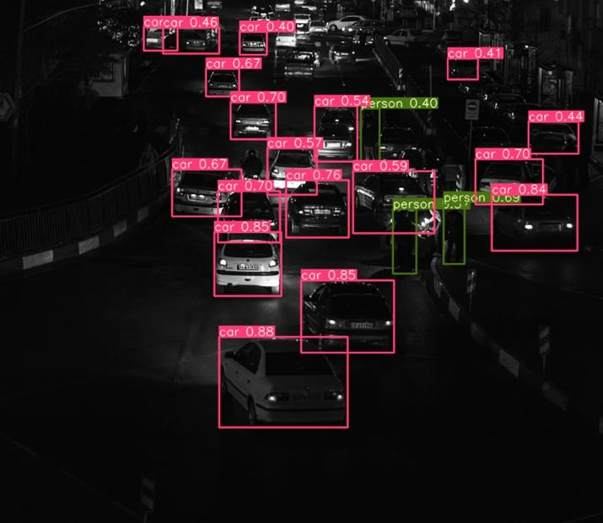
6
Example
RGB IMAGE
│
▼
Grayscale Conversion
│
▼
┌─────────────────────────┐
│ ▓▓▓ ███ │
│ │
│ ▓▓▓ │
│ ███ │
└─────────────────────────┘
One channel

4. Binary Image
A binary image contains only two intensity values, usually:
or:
It is generally obtained by applying a threshold:
where is the threshold.
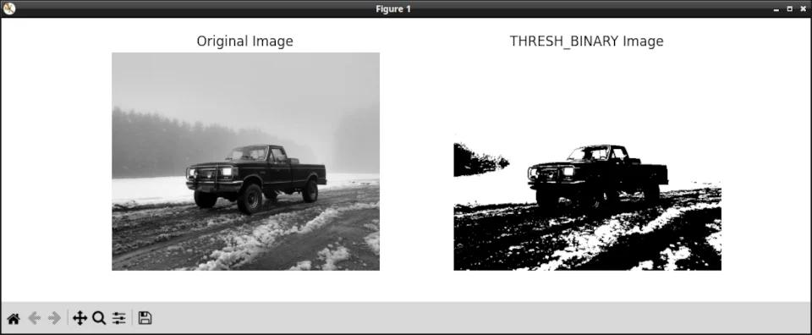
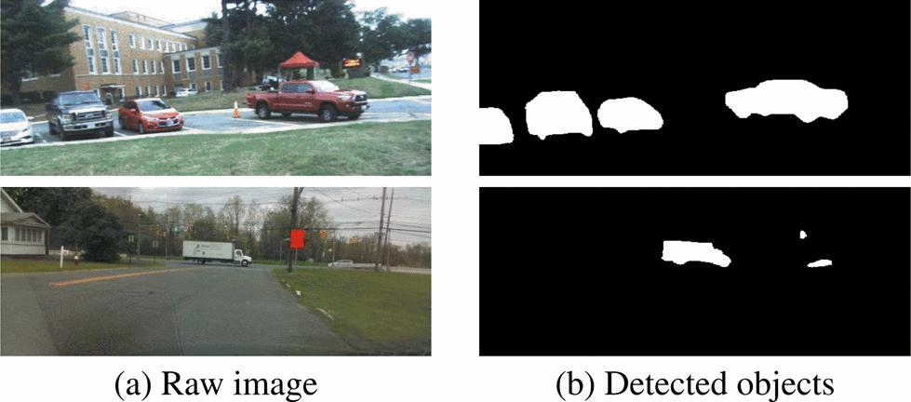
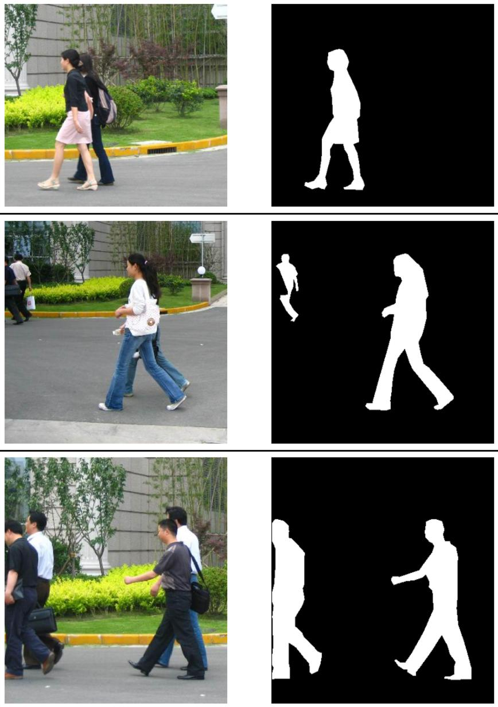
5
Example
GRAYSCALE
│
▼
THRESHOLDING
│
▼
BINARY IMAGE

████████████████
████ ███████
███ OBJECT ███
████ ███████
████████████████

Only:
0 = Background
1 = Object

5. Computational Efficiency
This is the first major comparison required by the question.
Suppose we have a:
image.
Number of pixels:
For RGB, each pixel has 3 channels.
For grayscale, each pixel has only 1 channel.
Therefore:
RGB

2,073,600 pixels × 3 channels
↓
More calculations

GRAYSCALE

2,073,600 pixels × 1 channel
↓
Fewer calculations

BINARY

2,073,600 pixels × 1 bit
↓
Very low data representation
Computational comparison
Representation | Channels | Computation | Memory | Information
RGB | 3 | High | High | Very high
Grayscale | 1 | Moderate/Low | Lower | Intensity + shape
Binary | 1 bit conceptually | Very low | Very low | Object/background

6. Effect on Edge Detection
Edge detection identifies sudden changes in intensity.
Common algorithms include:
- Sobel
- Prewitt
- Roberts
- Canny
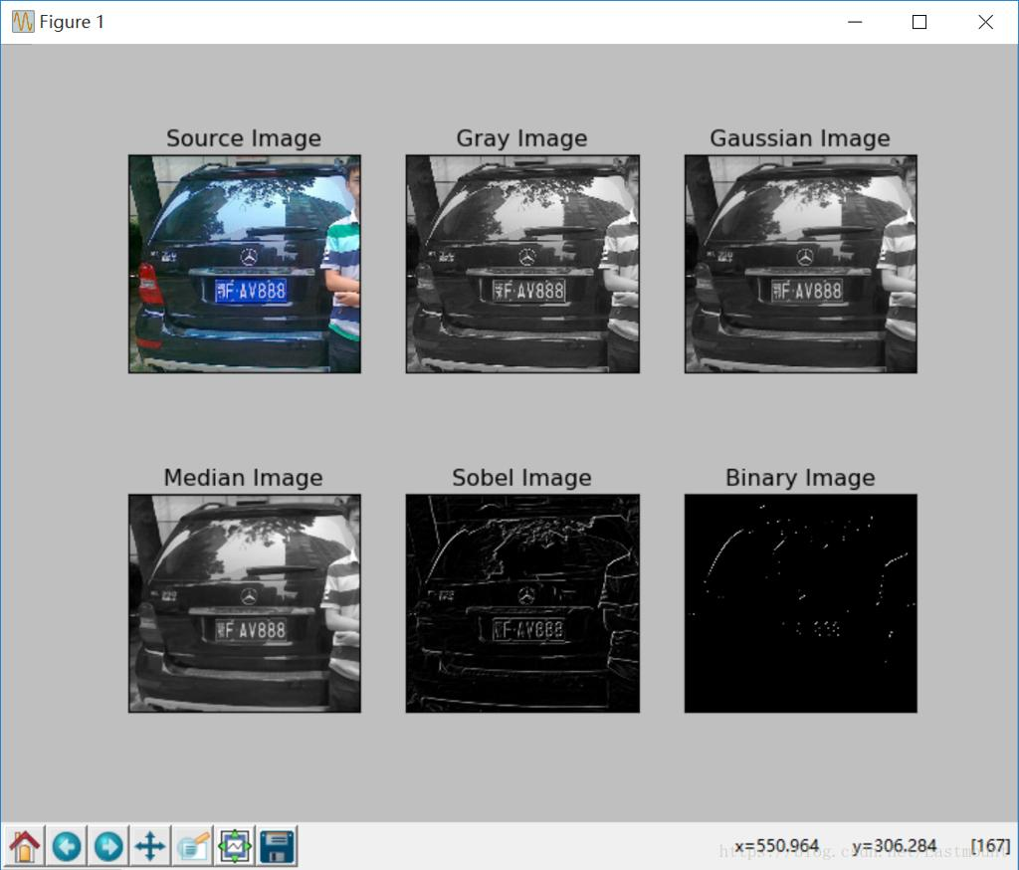
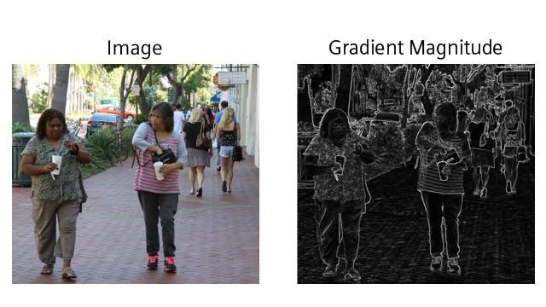
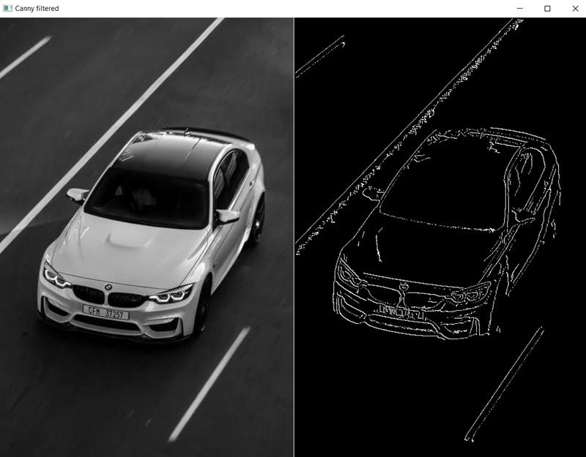
5
RGB Edge Detection
In RGB images, edge detection may need to consider changes in multiple color channels.
For example:
R channel → Edge
G channel → Edge
B channel → Edge
↓
Combine information
This increases computation.

Grayscale Edge Detection
The RGB image is first converted:
Then:
This is much simpler.
Result
RGB Image
↓
Grayscale
↓
Canny
↓
Edges
For most shape-based vehicle and pedestrian detection tasks, this provides a good balance between speed and useful information.

Binary Edge Detection
Binary images contain only two values.
This makes processing extremely fast.
However, thresholding may remove important details.
For example:
Original:

🚶
/|\
/ \

Binary:

█
███
█
█ █
Fine details may disappear.

7. Effect on Feature Extraction
Feature extraction identifies important information from an image.
Examples include:
- Corners
- Edges
- Contours
- Shape descriptors
- Texture features
- Local features
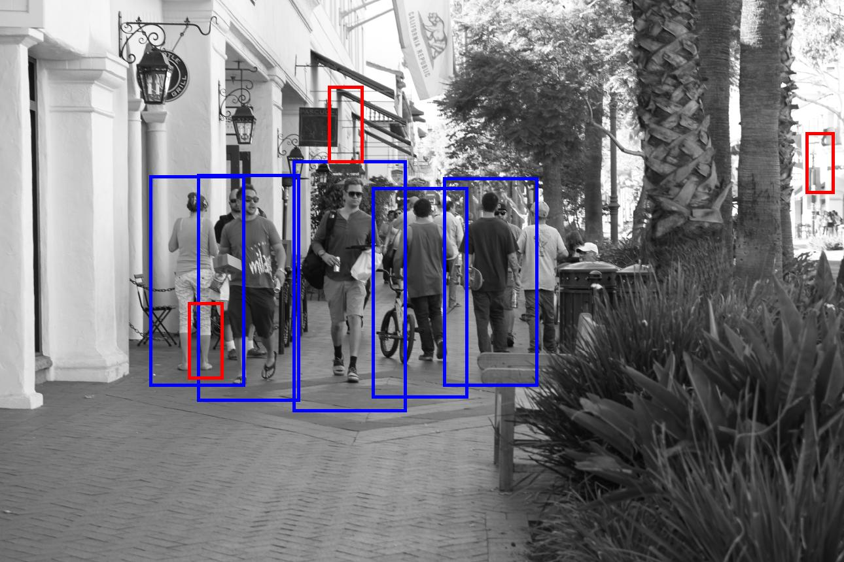
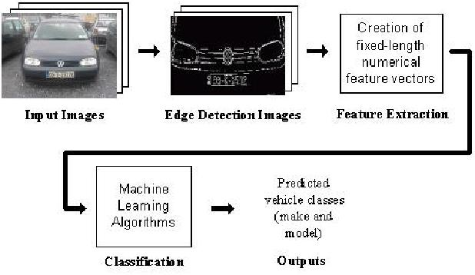
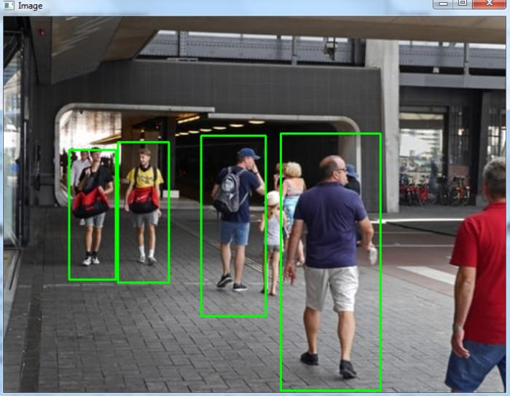
6
RGB
Provides:
- Shape
- Intensity
- Color
- Texture
Therefore, it contains the most information.
But:
More information = greater computational cost.

Grayscale
Provides:
- Shape
- Intensity
- Edges
- Texture
It removes color information but preserves much of the structural information required by classical feature detectors.
Therefore:
Good balance between accuracy and speed.

Binary
Provides mainly:
- Shape
- Object silhouette
- Foreground/background separation
But it loses:
- Texture
- Fine intensity variations
- Subtle boundaries
- Most color information
Therefore:
Extremely fast, but potentially less accurate.

8. Practical Surveillance Example
Imagine a surveillance camera observing a road.
The camera captures:
ROAD
────────────────────────

🚗 🚶
The system needs to detect the vehicle and pedestrian.
RGB approach
Camera
↓
RGB Image
↓
Feature Extraction
↓
Object Detection
Problem:
Large amount of data → high computation → lower FPS.
Grayscale approach
Camera
↓
RGB
↓
Grayscale
↓
Edge Detection
↓
Feature Extraction
↓
Object Detection
This reduces the computational workload while retaining important structural information.

Binary approach
Camera
↓
RGB
↓
Grayscale
↓
Threshold
↓
Binary
↓
Object Detection
This is very fast, but performance depends heavily on the threshold.

9. Major Problem With Binary Representation
Binary images can be very sensitive to lighting.
Imagine:
Daytime
Object = Dark
Background = Bright

↓

Easy thresholding
But at night:
Object = Dark
Background = Dark

↓

Poor separation
↓
Object may disappear
Similarly, shadows can be incorrectly classified as objects.
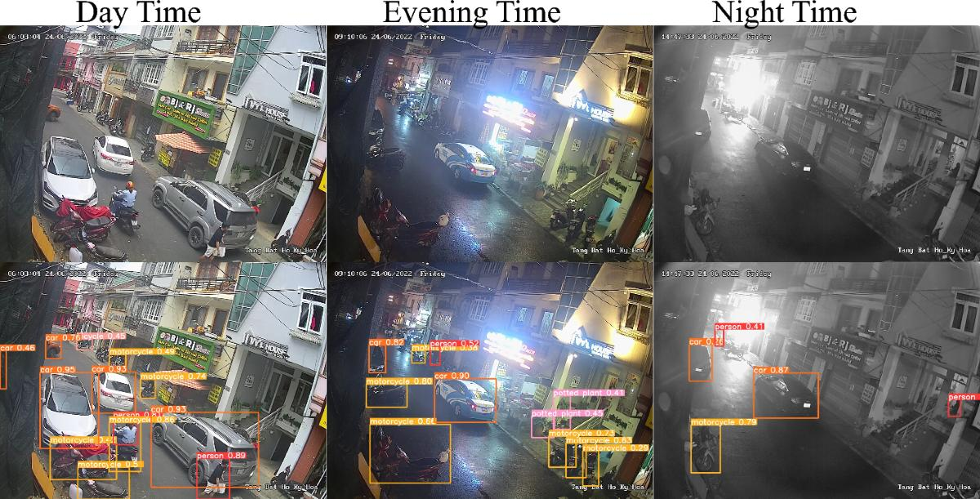
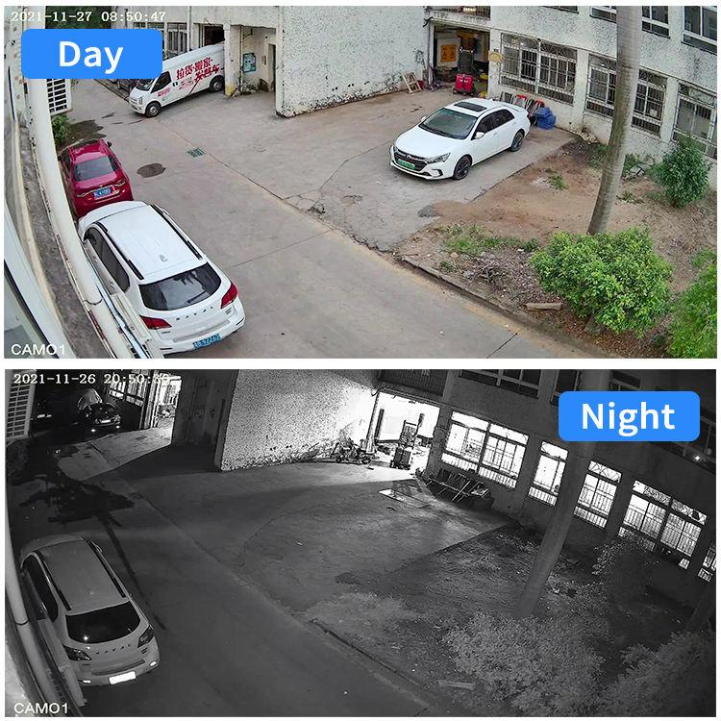
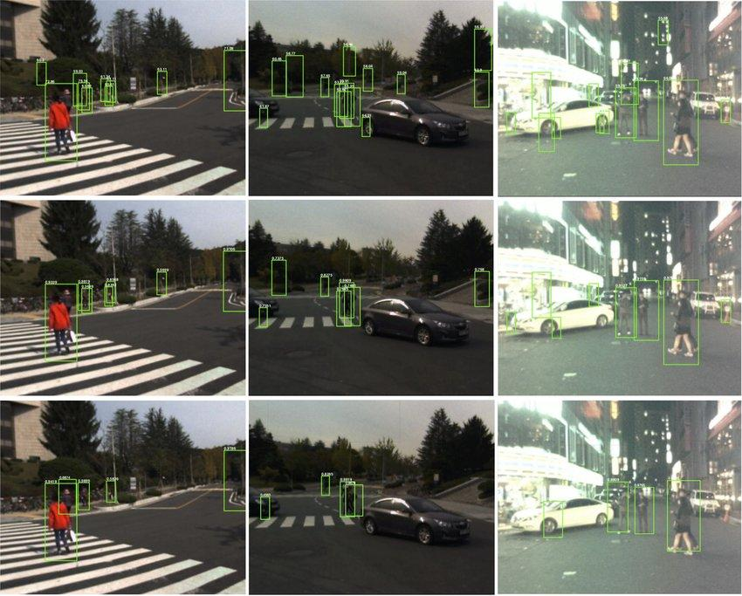
6
Therefore, binary representation is not always reliable for real-world surveillance.

10. Comparison: RGB vs Grayscale vs Binary
Parameter | RGB | Grayscale | Binary
Channels | 3 | 1 | 1 bit
Computational cost | High | Low/Moderate | Very Low
Memory requirement | High | Low | Very Low
Color information | Yes | No | No
Shape information | Excellent | Excellent | Good
Edge detection | Good but expensive | Excellent balance | Limited
Feature extraction | Rich | Good | Limited
Lighting robustness | Better information available | Reasonably good | Poor
Fine details | Preserved | Mostly preserved | Often lost
Real-time processing | More difficult | Very suitable | Very fast
Object detection | High potential accuracy | Good accuracy/speed balance | Application-dependent

11. Best Representation for This Case
Recommended: Grayscale
For the given scenario, grayscale is generally the most appropriate representation before classical edge detection and feature extraction.
Why?
Because it provides the best compromise between:
The pipeline becomes:
COLOR CAMERA
│
▼
RGB IMAGE
│
▼
GRAYSCALE CONVERSION
│
▼
NOISE REDUCTION
│
▼
EDGE DETECTION
(Canny/Sobel)
│
▼
FEATURE EXTRACTION
(HOG/Corners/etc.)
│
▼
OBJECT DETECTION
🚗 Vehicles
🚶 Pedestrians

12. Why Not Binary?
Binary is faster, but it throws away too much information.
For example:
Grayscale:

██████░░░░░░
████▓▓░░░░░░
████▓▓▓░░░░░
Different intensity levels are available.
After thresholding:
Binary:

██████░░░░░░
██████░░░░░░
██████░░░░░░
Fine details may be lost.
This can negatively affect:
- pedestrian shape recognition,
- vehicle boundaries,
- small objects,
- partially occluded objects,
- objects under varying illumination.

13. Important Computer Vision Point
You should not say that grayscale is always better than RGB.
The correct statement is:
For shape- and intensity-based real-time detection, grayscale usually provides the best computational/accuracy trade-off. However, if color is an important discriminative feature, RGB or a color-space representation may provide better detection accuracy.
For example, if the system needs to distinguish:
🚗 Red car vs blue car
then grayscale loses that color information.
But if the objective is simply:
🚗 Vehicle vs background
shape and intensity may be sufficient, making grayscale attractive.

14. Complete Case Study Diagram
You can draw this in your Computer Vision exam/assignment:
SURVEILLANCE CAMERA
│
▼
COLOR IMAGE
(RGB)
│
┌────────────┼────────────┐
│ │ │
▼ ▼ ▼
RGB GRAYSCALE BINARY
│ │ │
▼ ▼ ▼
High Cost Lower Cost Very Low Cost
│ │ │
▼ ▼ ▼
Edge/Feature Edge/Feature Threshold/
Detection Detection Shape Analysis
│ │ │
▼ ▼ ▼
High Detail Good Balance Information
⭐ BEST Loss
│ │ │
└────────────┼────────────┘
▼
OBJECT DETECTION
│
┌──────┴──────┐
▼ ▼
VEHICLES PEDESTRIANS

15. Final Answer / Conclusion
Case Study Conclusion: In a real-time autonomous surveillance system, directly processing high-resolution RGB images provides complete color information but increases computational complexity because three channels must be processed. Converting the image to grayscale reduces the data to a single intensity channel while preserving important structural information such as edges, contours, and shapes. This significantly improves the speed of edge detection and feature extraction with relatively small information loss. Binary representation provides even greater computational efficiency, but thresholding can remove fine object details and is highly sensitive to illumination, shadows, and background variations. Therefore, grayscale is the most appropriate representation for this application when using classical edge and feature-based detection, because it provides the best balance between computational efficiency, feature quality, and detection reliability. Binary images can be used as an additional preprocessing step when the foreground and background can be separated reliably.

Rubrics for Calculation

Criteria | Weig htage | Level 4 – Exemplary | Level 3 – Proficient | Level 2 – Developing | Level 1 – Beginning | Marks
Understanding of Case | 25 | Thorough understanding; clearly identifies all key issues | Good understandin g with most issues identified | Basic understanding  ; some issues missed | Poor understanding; problem not identified correctly
Application of Concepts | 25 | Effectively applies relevant concepts to analyze the case deeply | Applies appropriate concepts with minor gaps | Limited application of concepts | Fails to apply relevant concepts
Analysis | 20 | In-depth analysis with strong reasoning and insights | Good analysis with logical reasoning | Basic analysis with limited depth | Weak or no analysis; lacks reasoning
Solution Design | 20 | Innovative, feasible solutions with strong justification | Logical solutions with adequate justification | Basic solutions with weak justification | Incorrect or no solution provided
Clarity | 10 | Clear,  well-structured, and easy to understand | Organized and understanda ble presentation | Limited clarity and structure | Poor clarity; difficult to understand

Faculty In-charge
Signature:
Date:

